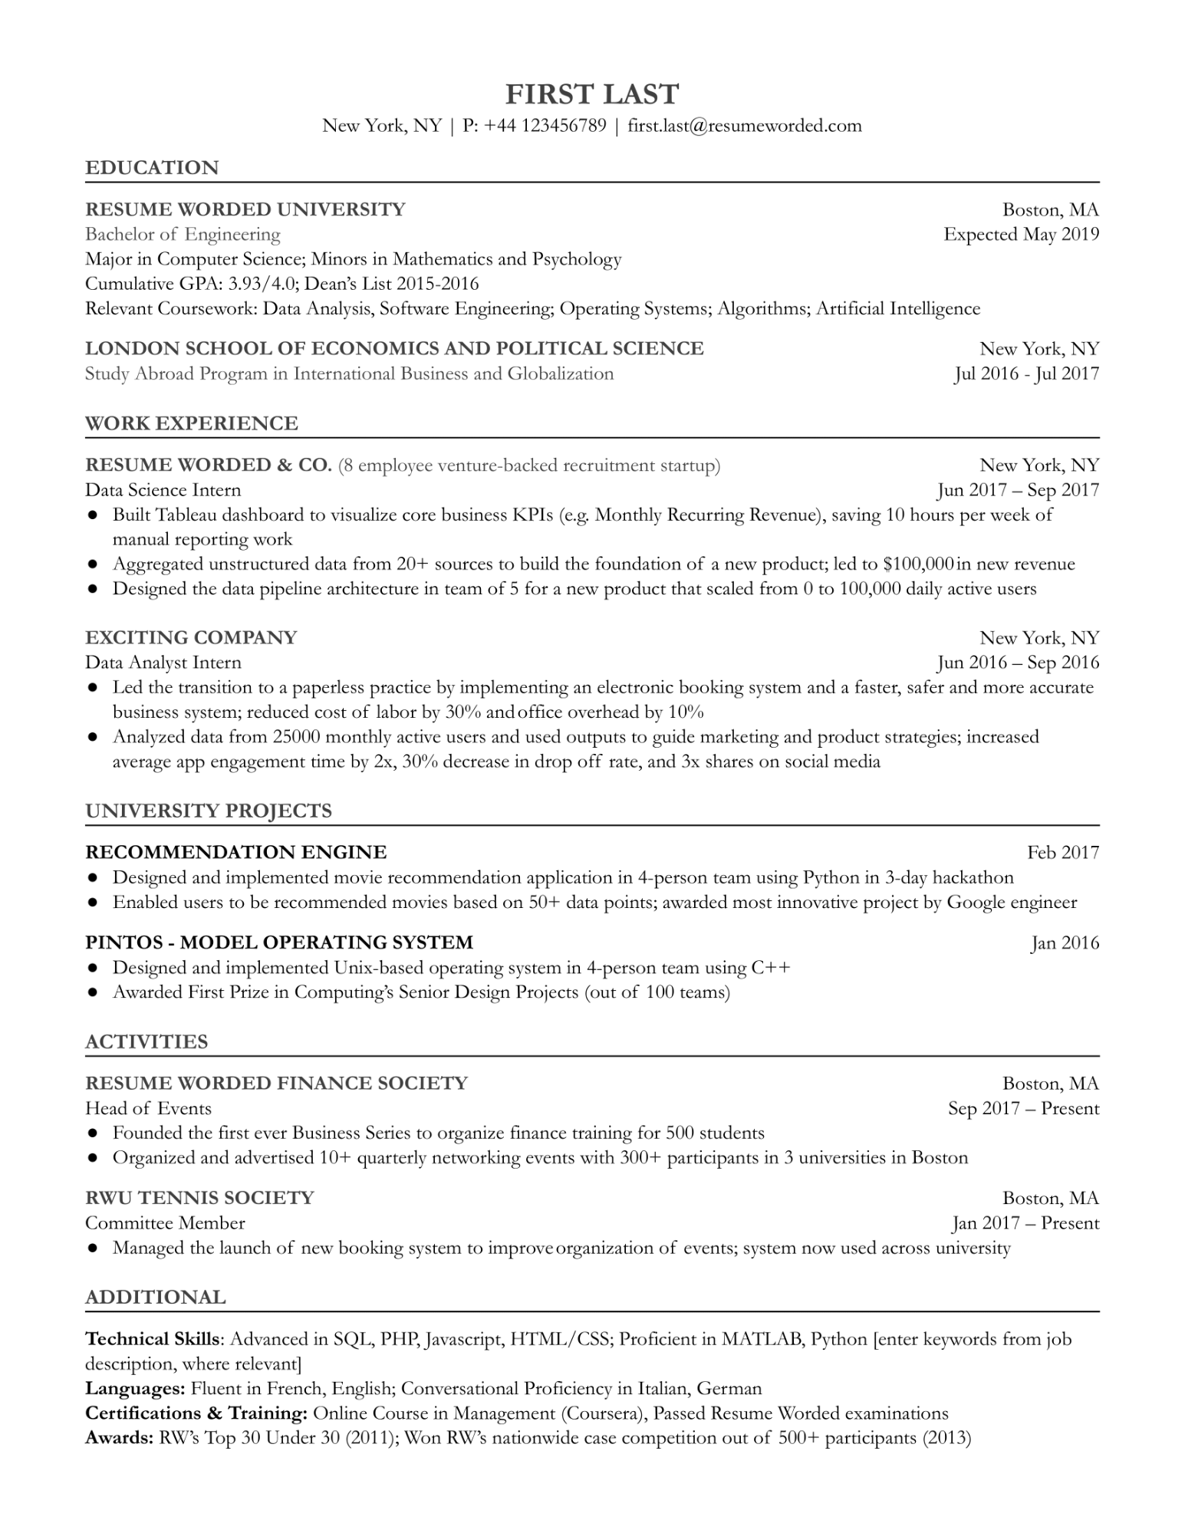
FIRST LAST
New York, NY | P: +44 123456789 | first.last@resumeworded.com
EDUCATION
RESUME WORDED UNIVERSITY
Bachelor of Engineering
Major in Computer Science; Minors in Mathematics and Psychology Cumulative GPA: 3.93/4.0; Dean's List 2015-2016
Boston, MA Expected May 2019
Relevant Coursework: Data Analysis, Software Engineering; Operating Systems; Algorithms; Artificial Intelligence
LONDON SCHOOL OF ECONOMICS AND POLITICAL SCIENCE Study Abroad Program in International Business and Globalization
WORK EXPERIENCE
RESUME WORDED & CO. (8 employee venture-backed recruitment startup) Data Science Intern
New York, NY Jul 2016 - Jul 2017
New York, NY
Jun 2017 - Sep 2017
• Built Tableau dashboard to visualize core business KPIs (e.g. Monthly Recurring Revenue), saving 10 hours per week of manual reporting work
• Aggregated unstructured data from 20+ sources to build the foundation of a new product; led to $100,000 in new revenue • Designed the data pipeline architecture in team of 5 for a new product that scaled from 0 to 100,000 daily active users
EXCITING COMPANY
Data Analyst Intern
New York, NY Jun 2016- Sep 2016
• Led the transition to a paperless practice by implementing an electronic booking system and a faster, safer and more accurate business system; reduced cost of labor by 30% and office overhead by 10%
• Analyzed data from 25000 monthly active users and used outputs to guide marketing and product strategies; increased average app engagement time by 2x, 30% decrease in drop off rate, and 3x shares on social media
UNIVERSITY PROJECTS
RECOMMENDATION ENGINE
Feb 2017
• Designed and implemented movie recommendation application in 4-person team using Python in 3-day hackathon • Enabled users to be recommended movies based on 50+ data points; awarded most innovative project by Google engineer PINTOS - MODEL OPERATING SYSTEM
• Designed and implemented Unix-based operating system in 4-person team using C++
• Awarded First Prize in Computing's Senior Design Projects (out of 100 teams)
ACTIVITIES
RESUME WORDED FINANCE SOCIETY
Head of Events
• Founded the first ever Business Series to organize finance training for 500 students
Jan 2016
Boston, MA
Sep 2017 - Present
• Organized and advertised 10+ quarterly networking events with 300+ participants in 3 universities in Boston RWU TENNIS SOCIETY
Committee Member
Boston, MA
Jan 2017 - Present
• Managed the launch of new booking system to improve organization of events; system now used across university
ADDITIONAL
Technical Skills: Advanced in SQL, PHP, Javascript, HTML/CSS; Proficient in MATLAB, Python [enter keywords from job description, where relevant]
Languages: Fluent in French, English; Conversational Proficiency in Italian, German
Certifications & Training: Online Course in Management (Coursera), Passed Resume Worded examinations Awards: RW's Top 30 Under 30 (2011); Won RW's nationwide case competition out of 500+ participants (2013)

